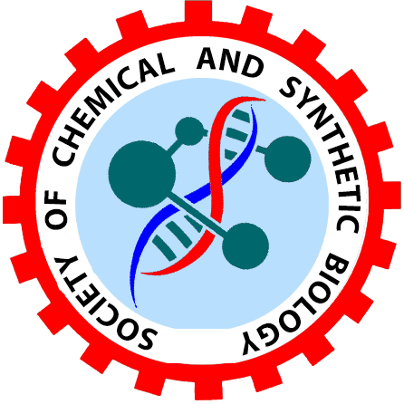
SCSB Synbio Grant Application form
FORMAT OF APPLICATION (Not exceeding 3-4 pages)

- Name of the PI:
- Affiliation:
- Name & Address of the Organization:
- Collaborator (s):
- Area of Application: Please tick appropriately Capturing Traditional Knowledge System Research & Development Infrastructure Creation
- Previous Engagement in Chemical and Synthetic biology Research (Give the list of Papers, Patents, Products, Technologies and Proof-of-Concept)
- Statement of the Problem:
- Proposed S&T Intervention:
- Methodology to be Adopted:
- Timelines viz-a-viz Deliverables/Outcomes:
- Proposed Budget
- Stakeholders of the Outcome:
- Signature from Principal/Dean
- Signature from PI/Co-PI
- Payment Proof
The application to be sent to as single PDF file to scsb2019@gmail.com

FOCUS OF THE CALL
- Pathway engineering/genome engineering in microorganisms and algae for:
- Small Molccules
- Specialty chemicals
- Polymers
- Biolubricants
- Hydrocarbons
- Improved enzyme systems
- Development of synthetic genetic parts and synthetic circuits
- Chemical biology
HOW TO APPLY?
- Proposals are required to be submitted to scsb2019@gmail.com.
- For more details, about registration and proposal submission, please log on to SCSB website (www.scsbindia.com)
- Last date for proposal submission: 15th August 2024
For further details, please contact:
SCSB President – scsb2019@gmail.com
WHO CAN APPLY
- Academia
- Start-ups
APPLICATION FEE:
The application fee is Rs.500.
PROJECT AMOUNT:
The Project amount is Rs.25, 000 to up to 1,00,000.

